**Project Design Phase-I**

**Solution Architecture**

|  |  |
| --- | --- |
| Date | 13 May 2023 |
| Team ID | NM2023TMID05684 |
| Project Name | CovidVision: Advanced COVID-19 Detection from Lung X-rays with Machine Learning or Deep Learnings |

**Solution Architecture:**

-Solution architecture is a complex process – with many sub-processes – that bridges the gap between business problems and technology solutions.

-The system aims to improve transfer learning and model integration by categorizing Lungs X-ray pictures into three categories:

-Normal, COVID-19, and infectious pneumonia. Choose the models ResNet-101 and ResNet-152 with best outcomes for fusion based on accuracy and loss value, and apathetically enhance its weight percentage during the training procedure.

-The system can obtain 97 percent accuracy in Lungs X-Ray pictures post training. In the diagnosing of lung nodules, this technique offers a higher accuracy than radiologist.

-It can assist radiologists enhance their efficiency levels and diagnostic performance as an additional diagnostic technique.

-Keywords: COVID-19, pneumonia, x-ray, convolutional neural networks, Coronavirus.

**Example - Solution Architecture Diagram:**

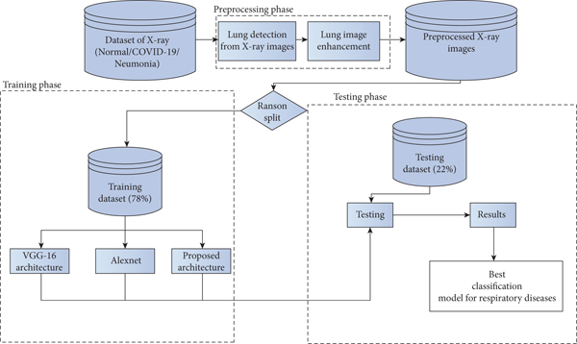

# *Figure 1: Architecture and dataflow diagram for Covid-19 using deep learning on lungs X-ray*